Title (Calibri, 14, Bold)
John Smith¹, John Smith², … (Calibri, 12)
¹Author affiliation. ²Author affiliation (Calibri, 11, Italic)
Email: jsmith@institution.es (Calibri, 11)
The body of your abstract begins here. It should be an explicit summary of your presentation that states the problem, the methods used, and the major results and conclusions. It should be single-spaced in 12 point Calibri font. References in square brackets before punctuation, not superscript. Be sure to adhere to the word limitation (250 words) not including references and not exceed 1 page. You can add up to 1 picture.

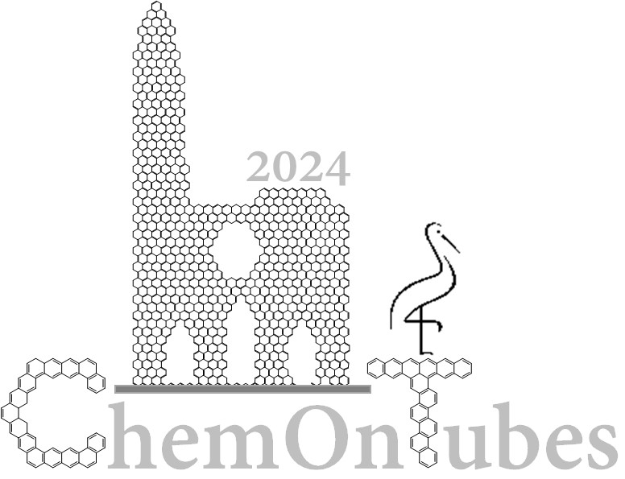
Figure 1. This is the caption for Figure 1

Instruction to send the abstract (to be removed): You should send the abstract as a Word document to chemontubes2024@unistra.fr by March 3rd 2024 for flash and oral communications and by March 15th 2024 for posters. The title of the document should include the name of the presenting author and the kind of contribution he/she is willing to present (O = oral; P = poster; F = flash communication). For instance: J.Smith_O.doc. Flash communication should be accompanied by a poster participation.

References
[1] N. Surname, Journal, Year, Vol, pg-pg. (Calibri, 10)

